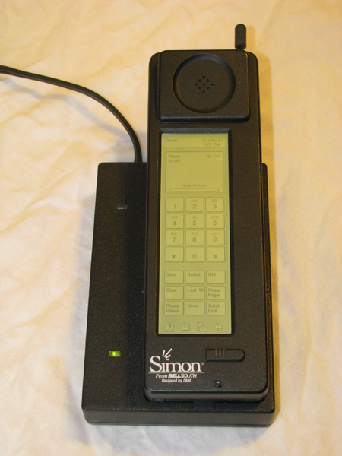
First Smart Phone

IBM Simon which was a joint venture between IBM and BellSouth is considered as the first smartphone in this world.
Designed in 1992,
launched to the public in 1993
Sold by BellSouth.
It combined the features of a mobile phone, a pager, a PDA, and a fax machine.
It also contained a calendar, address book, world clock, calculator, note pad, e-mail, send and receive fax, and games.
It had no physical buttons to dial with but a touchscreen. It was a highly advanced phone for that time.
After this many other companies started releasing smartphones. The Nokia Communicator line was the first of Nokia's smartphones starting with the Nokia 9000, released in 1996. Blackberry, Motorola, apple and every company released the product time to time.

- 1992 – The first smartphone was invented by IBM in 1992. It was nicknamed, “Simon,” and had a plethora of features including a calendar, address book, calculator, email service, and even a touch screen. At $899.00, though, most people could not afford it.
- 1996 – Nokia launched a series of smartphones in the late ’90s that were basically a cross between a cell phone and a PDA.
- 2000 – Ericsson developed the R380, a touch screen smartphone that used the Symbian operating system and had a foldable keyboard. It was the first all-in-one device to actually be called a smartphone.
- 2002 – This was the year the smartphone revolution really took off. Blackberry was introduced with its email services, as well as the Palm Treo and its full QWERTY keyboard and Ericsson’s P800 model. Several new features were added to smartphones including the MP3 player, camera, and wireless technology. Exchange Email also became popular.
- 2005 – The N-Series of smartphones was introduced to the market by Sony Ericsson. These devices were targeted at business people because of their computing capabilities.
- 2007 – Apple’s coveted iPhone was introduced with its massive app store.
- 2008 – The open-source, Android operating system started to take off, supported by Google, Intel, HTC, and a variety of other developers.

Operating System
Symbian
In 2000, the touchscreen Ericsson R380 Smartphone was released.
It was the first device to use an open operating system, the Symbian OS.
It was the first device marketed as a 'smartphone'.
Also in 2000, the Nokia 9210 communicator was introduced, which was the first color screen model from the Nokia Communicator line. It was a true smartphone with an open operating system, the Symbian OS.
It was followed by the 9500 Communicator, which also was Nokia's first cameraphone and first Wi-Fi phone. The 9300 Communicator was smaller, and the latest E90 Communicator includes GPS.

Windows
In 2001 Microsoft announced its Windows CE Pocket PC OS would be offered as "Microsoft Windows Powered Smartphone 2002

BlackBerry
In 2002 RIM released their first BlackBerry devices with integrated phone functionality and shifted the positioning of their products from 2-way pagers to email-capable mobile phones.

iOS
In 2007, Apple Inc. introduced its first iPhone
One of the first mobile phones to use a multi-touch interface, the iPhone was notable for its use of a large touchscreen for direct finger input as its main means of interaction, instead of having a stylus, keyboard, and/or keypad, which were the typical input methods for other smartphones at the time

Android
Android is an open-source platform backed by Google, along with major hardware and software developers (such as Intel, HTC, ARM, Motorola and Samsung, to name a few), that form the Open Handset Alliance.^{[57]}The first phone to use Android was the HTC Dream, branded for distribution by T-Mobile as the G1. The software suite included on the phone consists of integration with Google's proprietary applications, such as Maps, Calendar, and Gmail, and a full HTML web browser. Android supports the execution of native applications and a preemptive multitasking capability (in the form of services). Third-party apps are available via Google Play (released October 2008 as Android Market), including both free and paid apps.

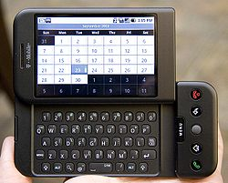

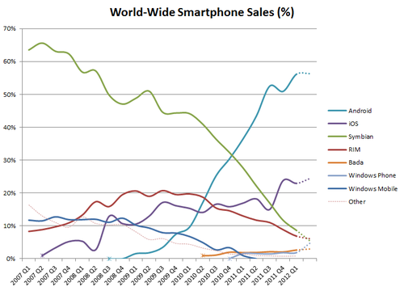

Market Share
Year | Android (Google) | Blackberry (RIM) | IPhone (Apple) | Symbian (Nokia) | Windows Mobile/Phone (Microsoft) | Other
2012-Q1^{[123]} | 56.1% | 6.9% | 22.9% | 8.6% | 1.9% | 3.6%

Historical sales figures
Figures in millions.
Year | Android (Google) | Blackberry (RIM) | IPhone (Apple) | Linux | Palm/WebOS (Palm/HP) | Symbian (Nokia) | Windows Mobile/Phone (Microsoft) | Other
2007^{[124]} |  | 11.77 | 3.3 | 11.76 | 1.76 | 77.68 | 14.7
2008^{[124]} |  | 23.15 | 11.42 | 11.26 | 2.51 | 72.93 | 16.5
2009^{[125]} | 6.8 | 34.35 | 24.89 | 8.13 | 1.19 | 80.88 | 15.03
2010^{[126]} | 67.22 | 47.45 | 46.6 |  |  | 111.58 | 12.38
2011^{[127]} | 219.52 | 51.54 | 89.26 |  |  | 93.41 | 8.77 | 14.24
2012-Q1^{[128]} | 81.07 | 9.94 | 33.12 |  |  | 12.47 | 2.71 | 5.09

Android Version Comparision

 | Release date | Key features added | Version name
Android 4.0.4 | 2012 Mar 28 | - stability improvements  - better camera performance  - smoother screen rotation | Ice Cream Sandwich
Android 4.0.3 | 2011 Dec 16 | - Social stream API in Contacts provider to show updates associated to your contacts  - Video stabilization and QVGA video resolution API access  - Accessibility API refinements for screen readers  - Calendar provider updates | Ice Cream Sandwich
Android 4.0.2 | 2011 Nov 28 | Minor fixes | Ice Cream Sandwich
Android 4.0.1 | 2011 Oct 19 | - Facial recognition (Face Unlock)  - UI use Hardware acceleration  - Better voice recognition (dictating/Voice typing)  - Web browser, allows up to 16 tabs  - Updated launcher (customizable)  - Android Beam app to exchange data through NFC  - Resizeable widgets | Ice Cream Sandwich
Android 3.2.6 | 2012 Feb 15 | Minor fixes | Honeycomb
Android 3.2.4 | 2011 Dec 15 | Added "Pay as you go" for tablets | Honeycomb
Android 3.2.2 | 2011 Sep 30 | Minor fixes | Honeycomb
Android 3.2.1 | 2011 Sep 20 | - Android Market updates including easier automatic updates  - Google Books updates  - Wi-Fi improvements  - Chinese handwriting prediction improved | Honeycomb
Android 3.2 | 2011 Jul 15 | - Optimizations for a wider range of tablets  - Compatibility display mode (zoom for fixed-sized apps)  - Media sync from SD card | Honeycomb
Android 3.1 | 2011 May 10 | - UI improvements  - Open Accessory API  - USB host API  - Mice, joysticks, gamepads... support  - Resizable Home screen widgets  - MTP notifications  - RTP API for audio | Honeycomb
Android 3.0 | 2011 Feb 22 | - Multi core support  - Better tablet support  - Updated 3D UI  - Google Talk video chat  - Google eBooks  - "Private browsing" | Honeycomb
Android 2.3.7 |  | - Google Wallet support for the Nexus S 4G | Gingerbread
Android 2.3.6 |  | - Voice search issue fixed | Gingerbread
Android 2.3.5 | 2011 Jul 25 | - Improved network performance for the Nexus S 4G  - Fixed Bluetooth issues on the Samsung Galaxy S  - Gmail app. improvements | Gingerbread
Android 2.3.4 | 2011 May 10 | - Open Accessory API  - Voice or video chat using Google Talk | Gingerbread
Android 2.3.3 | 2011 Feb 9 | - NFC API improvements (peer to peer communication...) | Gingerbread
Android 2.3 | 2010 Dec 6 | - Updated UI  - WebM video playback capability  - Improved copy/paste  - Social networking features  - Near Field Communication support  - Native VoIP/SIP support  - Video call support | Gingerbread
Android 2.2 | 2010 May 20 | - Speed improvements  - JIT implementation  - USB Tethering  - Applications installation to the expandable memory  - Upload file support in the browser  - Animated GIFs | Froyo
Android 2.1 | 2010 Jan 12 | - Updated UI | Éclair
Android 2.0.1 | 2009 Dec 3 |  | Éclair
Android 2.0 | 2009 Oct 26 | - HTML  - Digital zoom  - Microsoft Exchange support  - Bluetooth 2.1  - Live Wallpapers  - Updated UI | Éclair
Android 1.6 | 2009 Sep 15 | - Gesture framework  - Turn-by-turn navigation | Donut
Android 1.5 | 2009 Apr 30 | - Bluetooth A2DP, AVRCP support  - Soft-keyboard with text-prediction  - Record/watch videos | Cupcake
Android 1.1 | 2009 Feb 9 |  | Banana bread
Android 1.0 | 2008 Sep 23 |  | Apple pie
Android 0.9 | 2008 Aug 18

https://en.wikipedia.org/wiki/Android_version_history
http://socialcompare.com/en/comparison/android-versions-comparison

